RESOLUTION NO.__________

RE: CERTIFICATE OF APPROVAL UNDER THE
PROVISIONS OF BETHLEHEM ORDINANCE NO.
721 AND AS AMENDED.

WHEREAS, it is proposed to renew the food cart license for the cart located on the sidewalk in front of 15 W. 4th St.

NOW, THEREFORE, BE IT RESOLVED by the Council of the City of Bethlehem that a “Certificate of Approval” is hereby granted for the street vendor cart and operation.

Sponsored by: (s)

(s)

ADOPTED BY COUNCIL THIS DAY OF

(s)
President of Council

ATTEST:

(s)
City Clerk

STREET VENDOR AND STREET FURNITURE COMMITTEE

CASE # 001– It is proposed to renew the food cart license for the cart located on the sidewalk in front of 15 W. 4th St. OWNER/APPLICANT: 4th St. Club Entertainment LP/ Christopher Morales

The Committee upon motion by Ms. Pongracz and seconded by Mr. Cornish adopted the proposal that City Council issue a “Certificate of Approval” for the proposed street vendor cart and business described herein:

- The proposal to renew the food cart license for the cart located on the sidewalk in front of 15 W. 4th St. was presented by Christopher Morales.

- The cart has not been substantially changed in appearance since the last approval. The only changes noted were the removal of the fryer and replacement of the open flame grill with a flat top without an open flame.

- The motion to recommend renewal of license as previously approved carried unanimously.

CU: cu

By: 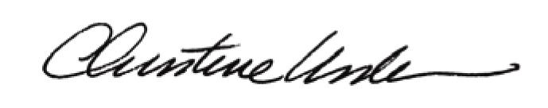

Date of Meeting: February 27, 2012 Title: Historic Officer

